|  |  |
| --- | --- |
| https://s.graphiq.com/sites/default/files/10/media/images/Lehigh_University_220097.png | http://static1.squarespace.com/static/521660f1e4b04942a67b77ae/t/5317a5dbe4b01676f1718529/1394058715906/atlsslogo_transparent.png |
| **Lehigh University** | | **Advanced Technology for**  **Large Structural Systems** |
|  | |  |

CEE 466 – Advanced Finite Element Methods

Project Report – Finite Element Analysis Program

By: Soheil Sadeghi

Instructor: Dr. Paolo Bocchini

December 2017

Contents

Introduction 1

Verifying Examples 2

Example One – Cantilever Beam 2

Example Two – L-shaped beam structure 5

Example Three - three story steel frame 9

Example Four – Tee frame 12

Example Five – indeterminate beam 15

Conclusion 17

# Introduction

In this project, the goal is to develop a program that using manually entered inputs, perform the dynamic analysis on 2D models consisting of linear elements. The operator is needed to enter all required inputs in three INPUT files as explained in the program manual. As a brief description of the entire program, it is worth to mention that the program digest inputs and generate mass and stiffness matrices and equivalent nodal load vectors for each elements. In addition, regarding the geometry of the program, rotation and Boolean matrices are generated. After these two steps, the program is ready to produce the global mass and stiffness matrix and total nodal load vector (containing both equivalent and point nodal loads). At this step, based on the desired type of dynamic analysis (modal or time history), either eigenvalue analysis or implicit dynamic analysis using Newmark method will be performed.

This program has the following features in addition to those mentioned in the first project:

* Compute mass matrix from direct formulations for both Timoshenko and Bernoulli elements and also the ability to derive mass matrix from shape function integration. In addition, different types of mass diagonalization algorithms have been implemented, such as ‘ad hoc’, ‘HRZ’ and ‘row summing’.
* Damping matrix is also needed for the time history analysis. In order to generate this, different approaches can be selected. For the Rayleigh damping, coefficients will be computed automatically based on the desired range of frequencies and damping ratios. Another option is to use Modal damping, which place a given modal damping ratio to all modes. The last option is to not assign damping to the model, which gives undamped response.
* The Newmark method is implemented to solve time history analysis. The operator can either decide to use constant or linear acceleration assumptions or give the manual values. The code also automatically check Δt for algorithm stability based on given Newmark parameters.
* The cool option that I have added to my program is the ability to plot modal displacements. In case of modal analysis, the program automatically asks for the desired mode to plot.

The program includes different sections and some of them were challenging for me. Here is a brief explanation of some of these challenges, to name but a few.

1. My main struggle in this project was to figure out how to deal with DOFs that have the boundary conditions, zero mass or zero stiffness. In particular, at the beginning, I supposed that for the condensation of mass and stiffness matrices for zero mass DOFs, I need to condensate each with their corresponding transformation matrix (called as T_k and T_m). However, after asking about the issue from the professor, I realized that both of these matrices have to be transformed with the same transformation (T_k).
2. Plotting the deformed shapes. For the plotting of the modal deformations, the position of each node has been updated with the model displacements. Then, the initial and updated positions are plotted with two different colors to show undeformed and deformed shapes. I had some pains to implement this code, especially for unordered nodal labels. However, finally I could solve the problem.
3. Generating mass matrices also was a section that took me a while to complete. However, it cannot be counted as a hard part.

In the following sections, each of the verifying examples are described and program results are shown and assessed. Please note that in all sections and plot, N and cm units are used in both texts and plots.

# Verifying Examples

## Example One – Cantilever Beam

In this problem, a cantilever beam made by two Bernoulli elements is under investigation. The section is a constant rectangular section with 10 cm height and 5 cm width. The beam is first analyzed for modal characteristics and then, the normalized modal shape of the first mode is imposed as the initial deformation and the time history of free vibration is performed. For the modal analysis, the model should be able to capture first four modes correctly. For validation purposes, the same geometry has been modeled in SAP2000 and results are compared.

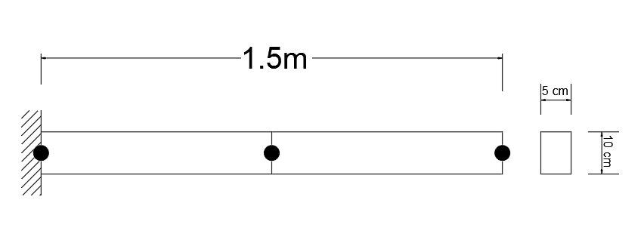

Figure 1 – Example One

In Figure 2, the modal analysis results from SAP2000 has been shown. In figure 3, the same results from the MATLAB program is provided. Notice that in SAP2000, for the fourth mode shape, the same axial deformation is given, which is not consistent with the MATLAB result. However, the values of frequencies and also modal deformations for the first three modes are totally consistent.

|  |
| --- |
|  |
|  |
|  |

Figure 2 – Mode shapes and frequencies

|  |  |
| --- | --- |
|  |  |
|  |  |

Figure . MATLAB modal analysis results

Please note that despite the unusual mode shape for Mode 3 in Figure 3 comparing to the axial mode in SAP2000 results, the order of vertical displacements are in of 10^-16, which means almost nothing. However, the longitudinal deformation is respectively considerable, which means that the mode shape belongs to the axial mode.

Since the modal part is done, the first modal deformation which is upscaled to give a 6 cm deflection at the tip is given as the initial deformation to the beam and the tip vertical displacement is plotted for half a second. It is also needed to check three cases, 1) average acceleration, 2) stable solution with algorithmic damping and 3) unstable solution.

For the case of average acceleration, the proper values for Newmark parameters have been assigned and Δt = 0.001s is chosen. Since the only excited mode is the first one, the tip displacement shows a perfect sinusoidal shape, which makes sense (Figure 4). The amplitude of the response is also 6 cm, which was the magnitude we scaled the initial imposed deformation with.



Figure . Constant acceleration Newmark response

For the case of algorithmic damping, γ = 0.6 and β = 0.3025 have been assigned for the Newmark procedure. As the response clarifies, a nice decaying behavior has been added to the response of the beam, without any explicit definition of damping (Figure 5).



Figure . Algorithmic damping effect

As the last case, the time step is increased to 0.05s which is higher than the Nyquist sampling rate and gives an unstable solution. It is an important point, because the instability is not caused by the numerical method, but the frequency content of the beam response (Figure 6).



Figure . Unstable solution

## Example Two – L-shaped beam structure

The second example is designed to check the ability of the code for tackling 2D problems. The geometry and loading properties of the problem are shown in Figure 7. In this example, both vertical and horizontal elements have been pieced by 0.1 m Bernoulli elements. The problem firstly wants to find first five modes and second, the time history response of the frame under an impact load.

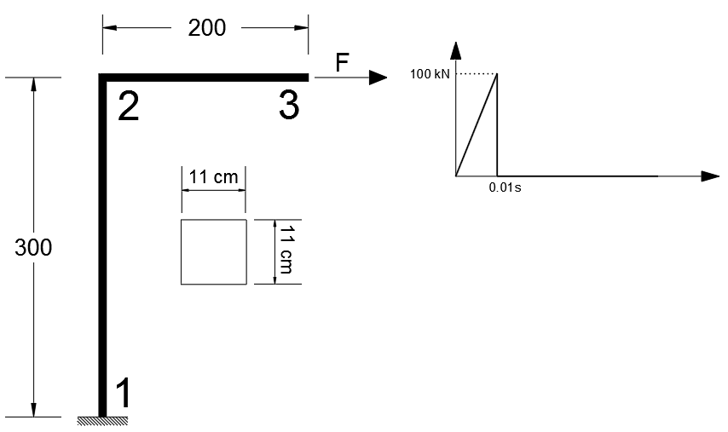

Figure 7 – Example Two

The mechanical properties of the material and the section are all based on given values in the problem description. Again, for the first step, modal analysis results from MATLAB program and SAP2000 are compared and then, the time history analysis will be done. The modal responses from SAP2000 and MATLAB program are presented in Figure 8 and Figure 9.

|  |  |  |  |
| --- | --- | --- | --- |
|  |  | |  |
|  | |  | |

Figure . Mode shapes and frequencies

|  |  |
| --- | --- |
|  |  |
|  |  |
|  | |

Figure . MATLAB modal analysis results

As the figures illustrate, the MATLAB program has very close modal results to the SAP2000 and that means the modal analysis is working very well. Thus, we are allowed to start the time history analysis. As the problem description requests, different time steps should be evaluated for this part. Before starting, let’s check the minimum time step against the Nyquist rate. Nyquist obligates us to use time steps less that 0.1377s which is already guaranteed, since all three time steps mentioned in the problem description are less than that, so they give stable solutions.

|  |  |
| --- | --- |
|  |  |

Figure . SAP2000 vs. MATLAB response for the horizontal disp. of roller

The comparison between SAP2000 and MATLAB response against the impact load at the roller support are depicted in Figure 10. Happily, they both show very similar response and the maximum displacement in both cases happen around 0.08s with the magnitude of 7.0 cm. The second monitoring point is the rotational response of the midpoint of the beam, which is shown in Figure 11. In this comparison, the responses are just inverted, because of the different definition of positive rotation in my code and SAP2000, which is not a big deal. However, the order of values and the peaks happen in the same places, which certify the accuracy of the MATLAB program.

|  |  |
| --- | --- |
|  |  |

Figure . SAP2000 vs. MATLAB response for the rotation of midpoint of beam

For the second phase, MATLAB results for different time steps are compared. It is expected to see less accuracy with less computation effort for longer time steps.

|  |  |  |
| --- | --- | --- |
|  |  |  |

Figure . Rotation comparison in different time steps

|  |  |  |
| --- | --- | --- |
|  |  |  |

Figure . Displacement comparison in different time steps

As it is obvious from Figure 12 and Figure 13, the accuracy of response decays as the length of time step increases. However, it is not the only drawback. By comparing the results for the largest time step with others, we can realize that the displacement (and also the rotation, with less clarity), is about three times higher! The reason for this huge overestimation is the fact that in this case, the length of time step is equal to the loading interval, which disables the algorithm to capture the immediate drop of the loading after 0.01s. Therefore, the effect of loading lasts longer and give such an unacceptable overestimation. However, in case of time step 0.001s, results are meaningful enough to be used for real application.

## Example Three - three story steel frame

As the third example, the dynamic behavior of a three story steel frame under a lateral point load is investigated. In this example, the mechanical props of material and sections are exactly as those given in the problem description. The discretization of the frame is up to us in a way that the model gives correct results for the first eight modes. The catch of this problem is to examine different types of mass matrix generation approaches. In this project, SAP2000 has been implemented to check results with. FE figure of the model is shown in Figure 14.

|  |
| --- |
|  |

Figure 14 - Example Three

As it is shown if the figure, columns of the frame are cut in two and beam in three pieces. The modal results for first eight modes are given in Figure 15 and Figure 16 for SAP2000 and MATLAB respectively.

|  |  |  |  |
| --- | --- | --- | --- |
|  |  |  |  |
|  |  |  |  |

Figure . Mode shapes and frequencies

|  |  |
| --- | --- |
|  |  |
|  |  |
|  |  |
|  |  |

Figure . MATLAB modal analysis results

The figures show very good consistency between SAP2000 and MATLAB code modal analysis results. As the next output, the roof displacement time history against the given loading is illustrated. Please note that according to the problem definition, for this problem the Rayleigh damping with parameters α and β = 0.5 is analyzed, which gives a highly damped system. Thus, as the Figure 17 indicates, maximum displacement decays rapidly after the loading is done. The match of SAP2000 and MATLAB results is also obvious.

|  |  |
| --- | --- |
|  |  |
| 1. SAP2000 | 1. MATLAB program |

Figure . Displacement comparison at the roof level

Finally, to have a good comparison for the effect of different mass matrix generation methods, as the last step, the modal frequencies for different mass matrices are compared in the following table.

Table . Frequency results for different mass matrices



As the table is showing, the values of frequencies are almost close up to the sixth mode. However, for the higher frequencies, the variations are more visible. It is also noteworthy that the row summing technique does not give a real solution, since it was at least one diagonal member in the mass matrix that was negative.

## Example Four – Tee frame

As an example of an unusual frame with a new form of loading, a Tee frame has been investigated. The material and section properties and also dimensions of the physical model are shown in Figure 18 and Figure 19. Like always, the first step toward a complete dynamic analysis is to perform modal analysis. In addition, as before, the MATLAB results are compared with the SAP2000 model of the same structure and accuracy of results are assessed.

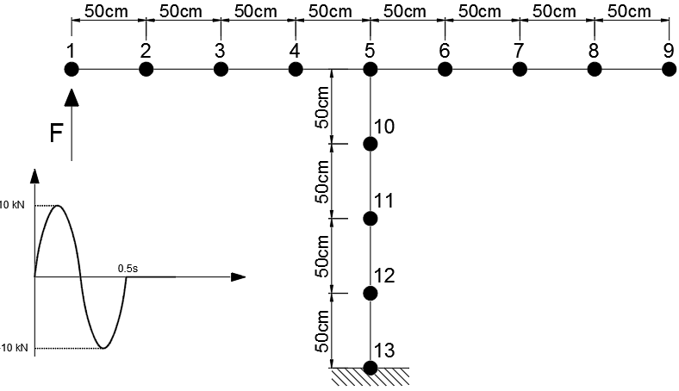

Figure . Example Four

|  |  |
| --- | --- |
|  |  |
| 1. Section dimensions | 1. Material properties |

Figure . Section and material definitions

As it is shown in Figure 20 and Figure 21, the consistency of MATLAB program and SAP2000 results of the modal analysis is very high. In fact, there is a trick to be able to capture such a good precision. In this example, Timoshenko beam element is used, instead of Bernoulli, since it was known from the former project that SAP2000 models wire frames with the complete Timoshenko beam. It is also interesting to know that if Bernoulli elements are used for this problem, modal frequencies and shapes differ considerably. However that still does not give the wrong answer.

|  |  |  |
| --- | --- | --- |
|  |  |  |
|  |  |  |

Figure . Mode shapes and frequencies

|  |  |
| --- | --- |
|  |  |
|  |  |
|  |  |

Figure . MATLAB modal analysis results

For the second part of problem, a time history analysis is held against a vertical sinusoidal load with a limited duration at the right tip. The loading pattern is shown in Figure 19. Moreover, the constant acceleration interpolation is used for the Newmark solver with γ = 0.6 and β = 0.3025 which create an algorithmic damping. Note that the same values are given for the SAP2000 model. Below, response time history of the left tip in both FE programs are shown.

|  |  |
| --- | --- |
|  |  |
| 1. SAP2000 result | 1. MATLAB program result |

Figure . Left tip response time history

As it is illustrated, two programs give very similar results and also same decaying power from the algorithmic damping added to the analysis.

## Example Five – indeterminate beam

As the last example, an indeterminate beam with five spans is modeled to demonstrate the capability of the program to solve indeterminate structures. As before, MATLAB results are validated with the SAP2000 model results. The geometry and boundary conditions of the beam are shown is Figure 23 and mechanical properties of the section also is presented in Figure 24. Note that the same material properties as the previous problem is selected for this example.

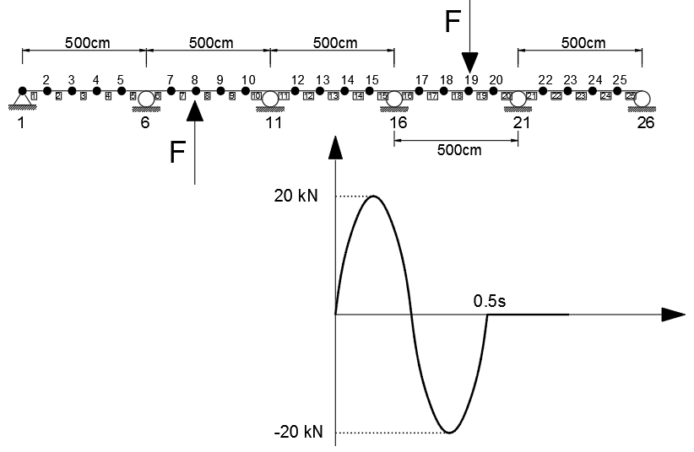

Figure 23 – Example Five

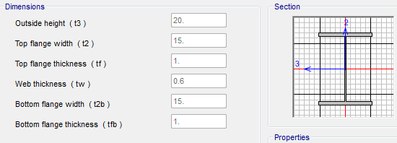

Figure . Section properties

As the first step, modal analysis of the problem in both FE programs are presented in Figure 25 and Figure 26.

|  |  |
| --- | --- |
|  |  |
|  |  |
|  |  |

Figure . Mode shapes and frequencies

|  |  |
| --- | --- |
|  |  |
|  |  |
|  |  |

Figure . MATLAB modal analysis results

The results shown above are indicative that the MATLAB program is successful enough to do modal analysis accurately. That gives a permission for the second part of the problem, which is the time history analysis of the beam against two opposite direction load with varying magnitude, as shown in Figure 23. The monitoring point in this section is node 14, which is the middle right node of the midspan. Rayleigh damping is acquired and the coefficients are automatically calculated based on the first six modal frequencies. The same damping method is used in the SAP2000 model to reach a better consistency in results. Figure 27 has compared displacement time history of node 14 with both FE program. Again, a very good consistency of results are obvious and the suitability of the MATLAB program to solve linear dynamic problems is guaranteed.

|  |  |
| --- | --- |
|  |  |
| 1. SAP2000 response | 1. MATLAB program response |

Figure . Response time history at node 14

# Conclusion

In this project, a Finite Element program was developed in the MATLAB software, which is capable of solving both static and dynamic programs linearly. The program gets inputs in different files and analyze them partially in numerous sub-functions and at the end, print out both inputs and outputs and also plot informative figures. The program still can improve considerably by adding extra features, such the ability to find internal forces and various time histories for different points.

To verify sanity of the program, five examples have been executed with MATLAB and compared with the benchmarks in SAP2000. In this report, extra features embedded in the program have been demonstrated in each of these examples, e.g. mode shape plot, different form of damping definition and time step controls for the stability. In general, the program was successful to analyze these illustrative examples. Some of the significant conclusions are listed hereafter:

* The more an element is refined, the better results can be expected in case of using Finite Elements for dynamic analysis. As a rule of thumb, the operator can expect to achieve valid modal results for half the number of DOFs. To solve this issue, refinement of the model is very helpful.
* In SAP2000 commercial software, the default flexural element is the Timoshenko element with the direct stiffness matrix and accordingly, the closest consistency between SAP and MATLAB program will be reached when Timoshenko elements with ad hoc mass matrices are used for the modeling.
* The effect of Newmark coefficients in the sanity of results has been investigated and the same conclusions that were drown in the class, have been observed in practice.